**Poole Elementary Kindergarten Newsletter** For the week of November 14-18 It’s A week!

Dear Parents,

We had so much going on last week, that there is not much to tell you about this week! We thank you for your participation in our Thanksgiving lunch, and our Veteran’s Day celebration. Last week was a lot of fun.

There are two things we need to draw your attention to. We have an early release day on Wednesday, December 7. Students will be released at 12:20. And… the last day of school before Christmas break is TUESDAY, December 20.

In Kindergarten this week...

**Reading:** We are finishing up our unit about Thanksgiving. We will compare the life of pilgrim and native American children to our lives today. We will also learn about crossing the ocean on the Mayflower! It’s going to be a GREAT week! (We didn’t quite get finished with everything on our plans last week because of all the special activities, so we bumped a few things to this week. Our sight words are *be, go, am.*

**Writing:** We are writing opinion papers. They will go something like this: I think _________, because ______________. Of course, we will be there to help them with the words.

**Phonics:** This week we are talking about LONG vowel sounds. We are also talking about rhyming words, beginning sounds, and syllables.

**Math:** We’re very excited to start our Measurement Unit this week. We will do a lot of comparisons (taller, shorter, more, less, heavier, lighter).

**Social Studies:** We will talk about the history and traditions of Thanksgiving throughout the month of November.

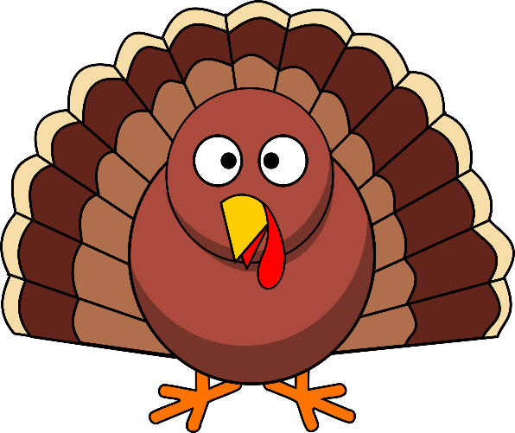

|  |  |
| --- | --- |
| **Upcoming Events** | **Reminders** |
| PENNIES FOR PAULDING!!!!!!  Thank you so much for all your help with this. Our school raised well over $1,000. We are so proud of our school.  **Thanksgiving Break- November 21-25**  We hope you have a wonderful Thanksgiving!  **Early Release Day- December 7**  **(students dismissed at 12:20)**  **Last day of school before Christmas is**  **TUESDAY, December 20.** | **Mondays are Quarter Hat Day. Students may wear a hat, if they bring a quarter! This money benefits Relay for Life.**    **Frozen Friday is every Friday. Students will receive a Frozen Treat for $1.00.**  Read to Succeed forms are due February 27. You must have 6 hours of reading recorded on your form to be eligible (please total your forms before sending them in!)      Please don’t forget to send an excuse when your child is out. Also, if you are changing the way your child goes home in the afternoons, we have to have that in writing. Please send us a note. |

**School/Home Connections/aka-*HOMEWORK*:**

* Practice writing first and last name

* Practice counting to 50 (or 100)

* Give your child 11-20 small objects... macaroni, pennies, toothpicks, etc., and let him/her put them in groups of “ten and some more” to determine the “teen number” they counted.

* Look around your house for objects to compare. Try to get your children to use the following words when comparing two objects: More, less, taller, shorter, heavier, lighter. Then ask them HOW they knew which object was taller, shorter, heavier, lighter, etc…

* Alphabet Recognition... matching upper and lower case letters

* Review our Phonics Sounds

* Review sight words

* Read 10-15 minutes a night to your child... It will make him/her a better reader! AND get you a FREE Six Flag ticket! ☺

Please don’t hesitate to contact us if you have any questions. Our email addresses are listed below!

Mrs. Baird: abaird@paulding.k12.ga.us Mrs. Burton: lburton@paulding.k12.ga.us

Mrs. Keilman: jkeilman@paulding.k12.ga.us Mrs. Upton: wupton@paulding.k12.ga.us